**Project Design Phase-II**

**Technology Stack (Architecture & Stack)**

|  |  |
| --- | --- |
| Date | 20 October 2022 |
| Team ID | PNT2022TMID41576 |
| Project Name | Emerging Methods for Early Detection of Forest Fires |

**Technical Architecture:**

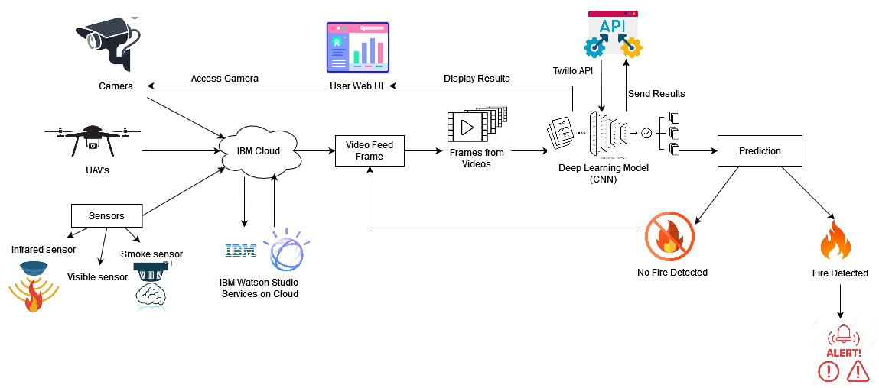

**Table-1 : Components & Technologies:**

|  |  |  |  |
| --- | --- | --- | --- |
| **S.No** | **Component** | **Description** | **Technology** |
| 1. | User Interface | The user uses the console to access the interface | Python/HTML, CSS, JavaScript and react.Js |
| 2. | Input | Video Feed | Web Camera/Video on a site |
| 3. | Conversion | Video inputted is converted into Frames | Frame Converter |
| 4. | Feeding the Model | The Frames are sent to the Deep learning model | Our Model |
| 5. | Dataset | Using Test set and train set , train the model | Data set from Cloud Storage , Database |
| 6. | Cloud Database | Database Service on Cloud | IBM DB2, IBM Cloudant |
| 7. | File Storage | File storage requirements | IBM Block Storage or Other Storage Service or Local Filesystem |
| 8. | External API-1 | Purpose of External API used in the application | IBM Weather API |
| 9. | External API-2 | Purpose of External API used in the application | User authentication |
| 10. | Deep Learning Model(CNN) | Gets the image, processes it, and detects the presence of fire | Faster RCNN, R-FCN, SDD, YOLO V3 |
| 11. | Infrastructure (Server / Cloud) | Application Deployment on Local System / Cloud Local Server Configuration:  Cloud Server Configuration : | Java/python, React.Js, JavaScript, HTML,  CSS, IBM Cloud, OPEN CV, Anaconda  Navigator, Local. |

**Table-2: Application Characteristics:**

|  |  |  |  |
| --- | --- | --- | --- |
| **S.No** | **Characteristics** | **Description** | **Technology** |
| 1. | Open-Source Frameworks | Python Flask framework is used | Technology of Opensource framework |
| 2. | Security Implementations | Mandatory Access Control (MAC) and Preventative Security Control is used | e.g. SHA-256, Encryptions, IAM Controls, OWASP etc. |
| 3. | Scalable Architecture | High scalability with 3-tier architecture | Web server – HTML ,CSS ,JavaScript  Application server – Python , Anaconda Database server –IBM DB2 |
| 4. | Availability | Use of load balancing to distribute traffic across servers | IBM load balancer |
| 5. | Performance | Enhance the performance by using IBM CDN | IBM Content Delivery Network |